2017-2018-1 Academic Year Fall Semester International Students General Course Introduction (Compulsory)

一、中国概况Survey of China
Credit：2
This course is designed to provide some necessary, basic and important information to the international students who are studying in China for their degree or Chinese language training programs.
 The course is a broad survey of China including:
 1. Quick Facts about China;
 2. China’s mountains & rivers;
 3. China’s geographic features;
 4. China’s brief history;
 5. Chinese culture highlights;
 6. China’s religions & legends;
 7. Traditional Chinese festivals and customs.
TEXTBOOK: China Panorama (English Version)
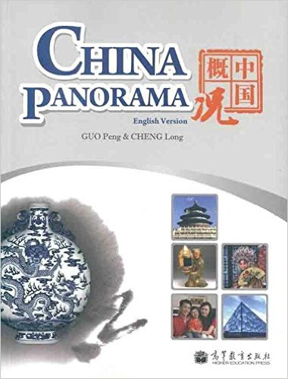

Product Details
- Publisher: 高等教育出版社; 第1版 edition (2012/5/1)
- Original language book name: China Panorama
- 平装: 212 pages
- ISBN: 9787040325478, 7040325470
- Brand Name: 高教社

二．高等数学/基础数学 Advance Math/Basic Math
3hours/week, Credit: 3 for Advance Math; 2hours/week, Credit: 2 for Basic Math
Mathmatics is the important subject in the general course, Especialy for the students who study in the science field. The mathmatics try to training the students has the logic way for thinking.
TEXTBOOK: 微积分
Publisher：高等教育出版社

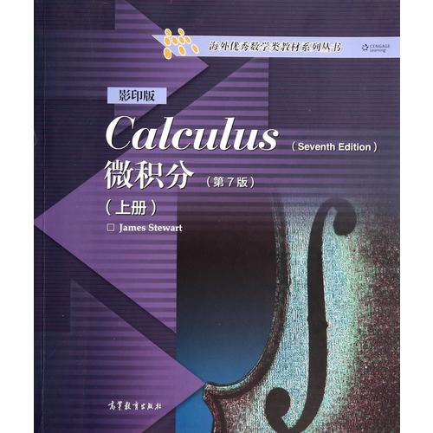
三．汉语一 Integrated Chinese I
4hours/week Credit: 4
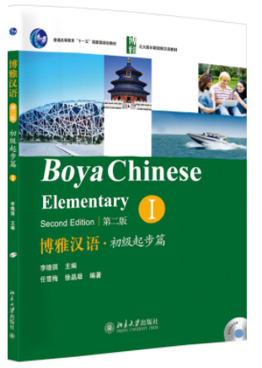
This course setted for the beginners. It is a comprehensive Chinese course; course covers four aspects skills training: listening, reading, speaking and writing. Through the study, students can understand and master good Chinese phonetic, can understand basic Chinese pragmatic rules, can use some basic patterns and vocabulary in daily life ,be able to read small paragraphs .Through studying this course, students can master 400-600 Chinese vocabulary, 300 - 400 Chinese characters, most of the students can pass HSK3 .

四． 中国法律简介 Introduction of Law
2hours/week Credit: 2
The law is one of the main powers to constrain and maintain order of society. This class introduces the framework of law by comparing the content of law and case in practice. Our class aims to learn the correlation and importance in law and life, to obey the basic rule of law and promote the attainment of law.
五． 计算机应用 Computer Science Application
Computer literacy (or fundamentals of Computer) helps students to understand the structure and working of computer. After learning this course, the students will identify every part of computer and know how to connect all the pieces and parts of computer together. Besides this, this course all introduce the basic concepts and important operations and tools of Microsoft Windows 7 operating system. Students all will learn about computer hardware and software, about the Microsoft Windows 7 operating system, and about the Internet. It also helps students learn about Word 2010, excel 2010, PowerPoint 2010 to create beautiful documents, Presentation and can use excel to process data. This course will provide a lot of practices to help students’ learning.

