2017-2018 Academic Year Semester-1 International Students Optional Course Introduction(Degree)

- 体育-乒乓球、羽毛球、网球，篮球，足球，太极拳。
2hours/week Credit：1
P.E. ：Table Tennis/Badminton/Tennis/Basketball/football/Teji boxing.
TEXTBOOK: N/A

2. 中国民俗艺术（剪纸）Chinese Folk Customs (Paper Cutting)
2hours/week Credit：2
In this course, we carefully select and introduce the essence of the Chinese Folk Customs and Arts ---- Paper-cutting, high acquaint the international students with basic knowledge on the Chinese Customs and Arts through class education and artistic practice, thus promoting cultural exchange between China and other countries.
TEXTBOOK: N/A
For example
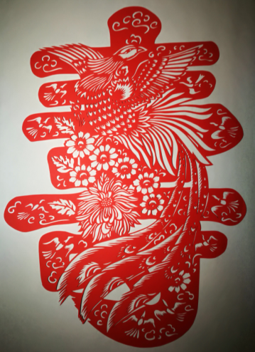
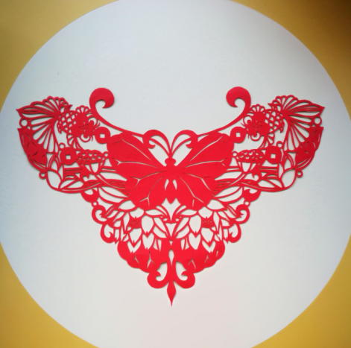

- 中国民俗艺术（民族舞蹈）Chinese Folk Customs(Dancing)
2hours/week Credit：2
In this course, we carefully select and introduce the essence of the Chinese Folk Customs and Arts ---- Folk Music and Dance, which acquaint the international students with basic knowledge on the Chinese Customs and Arts through class education and artistic practice, thus promoting cultural exchange between China and other countries.
TEXTBOOK: N/A
For example

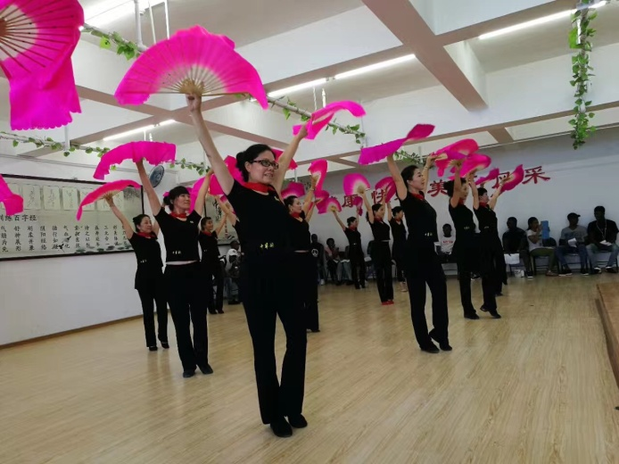

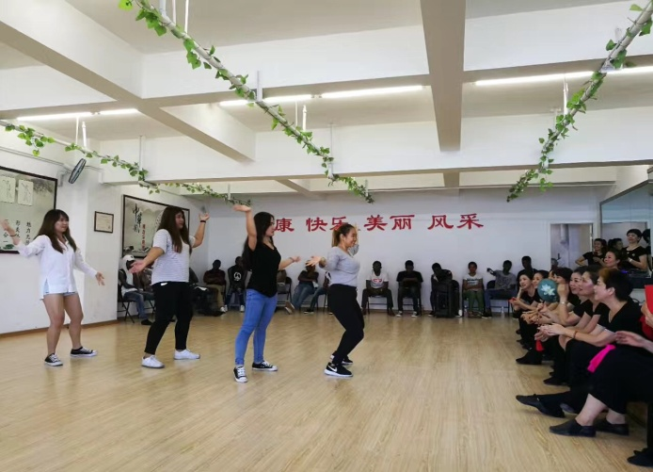

4. 汉字书写 INTRODUCTION TO CHINESE CHARACTERS
2hours/week Credit：2
I. Course Objectives
A. Learn about Chinese basic strokes、transformed and dependent strokes.
B. Learn the structure of Chinese characters, master single-component and multi-component characters.
C. Understand Chinese Components and Radicals，and know the difference.
D. Master Chinese Meaning Radicals and know how to make new characters with different radicals.
E. Master those frequently used characters, learn to read and write them.
TEXTBOOK: Easy Way to Learn Chinese Characters
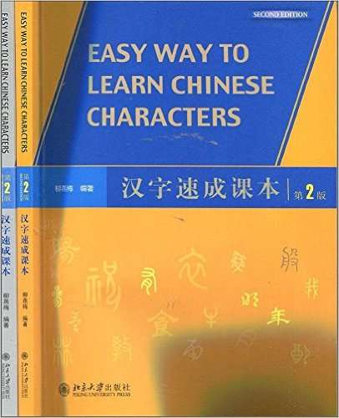

Product Details
- Publisher: 北京大学出版社; 第2版 edition (2014/4/1)
- Original language book name: Easy Way to Learn Chinese Characters
- Language: 简体中文, 英语
- ISBN: 9787301236352
https://www.amazon.cn/汉字速成课本-柳燕梅/dp/B00J85E5FE/ref=sr_1_1?s=books&ie=UTF8&qid=1476093117&sr=1-1&keywords=Easy+Way+to+Learn+Chinese+Characters

5. 中国功夫-南拳 Chinese Kungfu-Nanquan
2hours/week Credit：2
Nanquan refers to a classification of Chinese martial arts that originated south of the Yangtze River of China with emphasis on "short hitting" on the arms movement predominantly on southern styles
TEXTBOOK: N/A
For example:
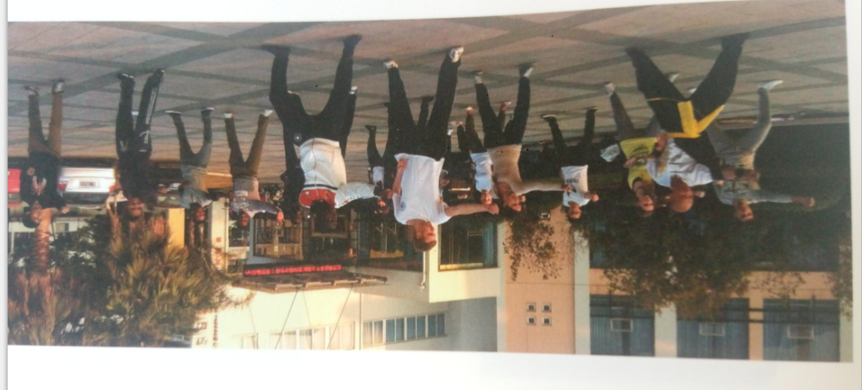

6. 中国概况-历史CHINESE HISTORY
2hours/week Credit：2
This course is intended to provide an up-to-date introduction to the development of Chinese history between the Xia Dynasty and the late 20th centuries. Particular issues addressed in the lectures will include: the changing social structure; households; local communities; gender roles; economic development; urbanization; religious changes; the change of monarchies and dynasties; rebellion, popular protest and civil war; education, literacy and print culture; crime and the law; poverty and social welfare, and so on.

7. 心理学 Introduction to Psychology
2hours/week Credit：2
This course requires no prior knowledge in psychology and will be covering many basic elements of psychology. This course will introduce the basic history of psychology and how psychology gradually transformed into a field of science that explores behaviors and mental processes. Throughout the course, you will come to understand the biological bases of many daily behaviors (i.e. eating, sleeping, learning, chatting, crying, and etc.) and more importantly the reasoning (mental processes) behind these behaviors. We will also discuss the development stages that humans go through during a lifetime, and how personalities, characteristics, meaningful relationships are built/destroyed as people share laughter, strife, hate, and other emotions (communicating their feelings) with one another.
TEXTBOOK: The Evolution of Psychology
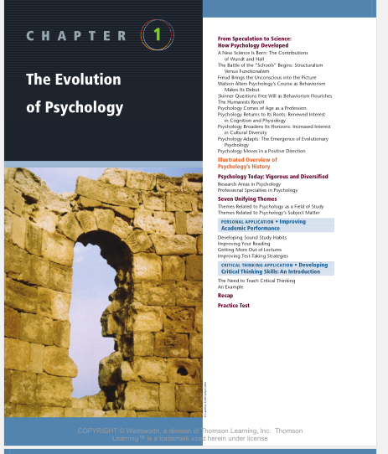

8.中国音乐 Introduction of Chinese Music
2hours/week Credit：2
This course aims to introduce Chinese music to international students. It will give students a broad overview of Chinese music, focusing on Chinese instrumental music, Chinese opera, folk songs, pop music with strong Chinese flavor and Chinese traditional musical instruments. By the end of this course, students will be able to recognize different Chinese musical instruments, know some famous Chinese instrumental music. They will also be able to learn to sing several famous Chinese folk songs and pop songs，have an understanding of Chinese opera，know some famous composers and performers. They will also have a deeper understanding of Chinese culture through class discussion.
9. 跨文化交际 Cross-cultural Communication
2hours/week Credit：2
This course is about knowledge, skills and practice of cross-cultural communication for International Trade majors and other foreign business related students at the elementary level. It is intended to offer learners relevant knowledge and skills in cross-cultural communication, so as to prepare them a better foundation for their future cross-cultural communication.）Principal Contents
Origins of Chinese culture and culture of English speaking countries; Differences between Chinese culture and culture of English speaking countries; Some major works on cross-cultural communication; Theories of cross-cultural communication; Theories of language communication; Cross-cultural communication skills and case studies; Learner practice of cross-cultural communication, including practice of an introduction of a place of interest (in English) to a foreigner/a group of foreigners.）
TEXTBOOK: Fundamentals of Intercultural Communication
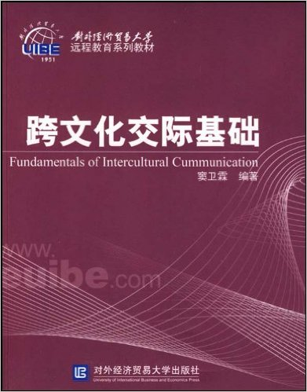

Product Details
- Publisher: 对外经济贸易大学出版社; 第1版 edition (2007/4/1)
- Language:
ISBN: 9787810788137

10. 走进温州 Taste Chinese In Wenzhou
Study hours：24 Classes （Theory: 8；practice：16）Credit：1
This course is closely linked to the theory and practice, students can understand deeply in the first semester more Wen Zhou local conditions and customs, know basic Chinese, travel and to experience the Chinese culture. Through a number of activities, feel the beauty of the humanities, history, Wenzhou, to cultivate students’ ability to friend to know China.
Task: 1.Master basic daily spoken Chinese; 2. A preliminary understanding of the characteristics of Wenzhou city (landscape features, folk customs, cultural features), feel Wenzhou; 3. Through a series of experience activities, to further understand China and the world's culture.
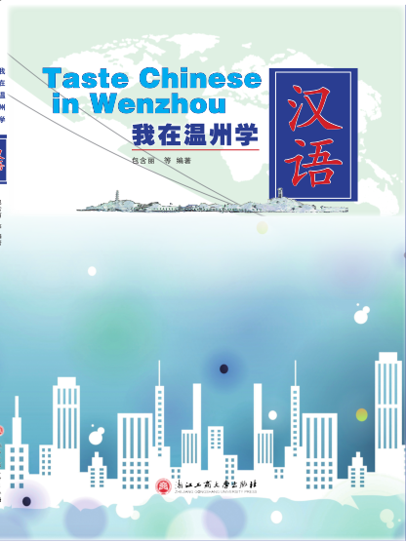

Publisher: 浙江工商大学
Language: 简体中文, 英语

